Lab Assignment 1
Linux Basics and Sensors

Part 1-Linux Basics
In this course, we will do multiple hands-on labs related to both Internet and Things. In some of these labs, we will utilize two well-known open-source simulation platforms, GNURadio and Network Simulator 3 (NS3). Both simulators run in a Linux environment. As some of you may not have worked in Linux before, in Part 1 of this Lab Assignment we will familiarize ourselves with some Linux basics. More specifically, we will learn to

- Use some basic Linux commands
- Install a package or software
- Use SSH and SCP

- Installing Linux Virtual Machine

Method 1 (Recommended): You can install the following VirtualBox virtual machine (VM) instance with Ubuntu, which already includes the GNURadio and NS3 simulators. (Warning: The compressed VM instance has a size of about 5GB, so it may take a while to download.) The Linux virtual machine can be downloaded and installed via the link below:
IoT_VirtualBox

Method 2: Alternatively, you can install VirtualBox + Ubuntu 18.04 LTS from:

VirtualBox: https://www.virtualbox.org/wiki/Downloads
Ubuntu 18.04 LTS – Desktop: https://releases.ubuntu.com/18.04/

and then install GNURadio and NS3 (to be used in later in later lab assignments)
GNURadio: https://kb.ettus.com/Building_and_Installing_the_USRP_Open-Source_Toolchain_(UHD_and_GNU_Radio)_on_Linux (Install GNURadio in ~/Gnuradio/trunk)

NS3: https://qizhu8.github.io/PersonalWebsite/build/html/Network/NS/NS3/NS3-installation/NS3-installation-Ubuntu.html

- Access RPI Homepage Server
At the end of this part, you will create a small personal webpage. Before you can access your website, we need to install some required software packages.
In Linux, software can generally be installed in two ways:
- Using a package manager (the recommended approach), or
- Compiling the source code.
Different Linux distributions use different package managers (for example, apt on Ubuntu and yum on CentOS). In this course, our VM instance is running Ubuntu 18.04 LTS, and all installation commands in this lab have been tested on that version.

Update and Upgrade System Packages

Before installing any software, ensure your package lists and installed packages are up to date:

sudo apt update # Refresh package list
sudo apt upgrade -y # Upgrade all installed packages

Tip: On Ubuntu and Raspberry Pi OS, apt is preferred over apt-get for interactive use.

- Installing openssh-server and inet-tools.
SSH (Secure Shell) is a protocol that establishes a secure channel over the network between your local host and a remote machine, allowing you to execute commands remotely. By default, Ubuntu includes the SSH client, which allows it to initiate connections to other machines. However, it does not include the SSH server, which is required to allow remote access into your machine. Fortunately, installing the SSH server is straightforward. Open a terminal and run the following command:

sudo apt install -y openssh-server net-tools

Then enter the super-user password, usually your current user password, and press y to confirm the installation. Done!

openssh-server: Enables SSH access

net-tools: Provides ifconfig, netstat, etc.

Start and enable the SSH service:

sudo systemctl enable --now ssh

Verify service status:

systemctl status ssh

Check Network Interfaces

Instead of ifconfig, use the modern ip command:

ip addr show # Display all network interfaces and IP addresses
ip link show # Show link-level information

- Login via SSH and publish a short bio:
RPI provides each student with space to host a personal website under the hostname web1.ecse.rpi.edu.
- Your username is your RIN (RPI ID).
- Your password is the same as your standard RPI credential (the one you use to log into LMS).
We will use SSH to connect to the RPI homepage server, and then use SCP to upload a text file. This will allow you to verify that your account is working and that you can publish content to your personal webpage.

A typical SSH command to construct the connection reads as

ssh [-y] <remote username>@<remote Ip or hostname>

The -y flag tells SSH whether to prepare for GUI data transmission and the SCP command used to send file/folder from A to B reads as

scp <path to the file in A> <target in B>
scp -r <directory in A> <target directory in B>

The -r flag indicates whether to recursively upload everything inside the folder, i.e., upload the whole folder.

To access the homepage server, we use the following command:

First, you will need to SSH to web1.ecse.rpi.edu with your RPI ID and password. i.e.

ssh ezemac@web1.ecse.rpi.edu

NB: If you are outside the RPI LAN, you must first connect through the School’s VPN; otherwise, the server will be unreachable.

Upon your first login, a home directory will be created automatically at /home/<your RPI ID>/. Within this directory, there will be a subdirectory named public_html.

After logging in, you can list the contents of your directory using the ls command.

To move to the public_html directory, use the cd command.

# Enter a folder named public_html
cd public_html

# Go back to its upper-level folder
cd ..

# Check current path
pwd

Place any files you want to be publicly available into the public_html directory. For example, if you create a file named bio.txt, it will be accessible at:

https://web1.ecse.rpi.edu/~<your RPI ID>/bio.txt

Use scp to upload files from your local system to the server. The command structure is:
scp <path to local file> <your RPI ID>@web1.ecse.rpi.edu:/home/<your RPI ID>/public_html/

e.g.,
scp ~/Documents/bio.txt ezemac@web1.ecse.rpi.edu:/home/ezemac/public_html/

After doing that, you can use your browser to read the file you uploaded with

e.g., https://web1.ecse.rpi.edu/~<your RPI ID>/

Include the URL to access your bio in your report.

- More on Basic Linux Commands
Some basic Linux commands may be found in the link given below:

https://maker.pro/linux/tutorial/basic-linux-commands-for-beginners

Familiarize yourself with the following commands:

cd mkdir pwd ls mv cp rm touch man zip unzip sudo ps top grep chmod chown

Furthermore, you can install a packet/software or updates using the commands below:

sudo apt-get update # update the software source list
sudo apt-get install <packet name> # install the packet/software

Part 2 - Sensors

- Introduction
In this part of the lab, you will use a Raspberry Pi (RPi) to interact with sensors. Each student will receive one RPi (with an SD card and reader), while the sensors are available in the IoT Lab (JEC 5312). As an embedded platform, the RPi provides 40 GPIO (General-Purpose Input/Output) pins that can be used to connect sensors or peripheral circuits. Since the RPi runs a full operating system, it natively supports standard communication protocols such as I²C, SPI, and Serial communication.
Compared to the C8051 chip you may have used in LITEC, you do not need to write specific drivers to send and receive bytes by manually interacting with the low and high voltage of a pin. Instead, you can rely on built-in libraries and kernel support to handle these protocols.
In summary:
- You will first configure your RPi.
- Next, you will use it to interface with different types of sensors.
- Finally, you will build a simple RFID reader application.

- Decide your way to complete the configuration
Before we get started, please answer the following question and proceed accordingly:

Do you have a monitor with HDMI interface, a full-size HDMI cable, a USB keyboard and a USB mouse?

If your answer is Yes, you can skip the next question and follow the instructions provided below to set up your RPi:

- Boot up RPi with HDMI connection
- Connect to the Wi-Fi Network with Monitor
- Enable SSH through GUI
- SSH to your RPi
- Changing your password
- Transferring files to the Raspberry Pi

If your answer is "No," procure an SD card reader (provided in a ziplock bag), connect it to the RPi, and proceed to follow the instructions below to set up your RPi:

- Boot up RPi without HDMI connection.
- Connect to Wi-Fi without a Monitor and by hacking the Raspbian system
- Enable SSH through OS Hacking
- SSH to your RPi
- Changing your password
- Transferring files to the Raspberry Pi

(If you would like to try wired Ethernet connection, you should connect your RPi to a LAN port of your router and skip the Wi-Fi configuration step.)

Boot up RPi with HDMI connection
If not already available, flash the micro-SD card with the Raspberry Pi OS (https://www.raspberrypi.com/software/). Insert the micro-SD card into the Raspberry Pi. Connect the Raspberry Pi to a display via an HDMI cable and attach a USB keyboard to the Raspberry Pi. Finally, plug your Raspberry Pi power supply into the Raspberry Pi via the micro-USB port. The order of the last two operations matters. You must plug in HDMI cable first and then plug in the power cable. Otherwise, the HDMI interface won’t have any signal.

Boot up RPi without HDMI connection
If not already available, flash the micro-SD card with the Raspberry Pi OS (https://www.raspberrypi.com/software/). Insert the micro-SD card into the Raspberry Pi. Once you plug in the power cable (the micro-USB cable), RPi will boot up automatically.

Connect to the Wi-Fi Network with Monitor
1. At the login prompt, log into the Raspberry Pi with the default username: pi and password: raspberry
2. Use the Wi-Fi icon on the top-right corner and set up the Wi-Fi connection.
3. Confirm that the Raspberry Pi is connected to the internet using, for example, use the command: traceroute www.google.com

Note that, since ping command is filtered out by firewalls on RPI campus network, ping www.google.com may not give you any feedback if you are on campus. More details about firewalls are going to be introduced in later lectures.
You can also configure the wireless network via sudo raspi-config->Network.

Connect to Wi-Fi without a Monitor and by hacking the Raspbian system
Use your computer to access the micro-SD card with a card reader. You should see a disk named boot. Add the wpa_supplicant.conf file under the top level of boot by following the instruction https://www.raspberrypi.org/documentation/configuration/wireless/headless.md.

The country code is "US." After making modifications to the wpa_supplicant.conf file, it should be something like this:

country=US
ctrl_interface=DIR=/var/run/wpa_supplicant GROUP=netdev
update_config=1

network={
scan_ssid=1
ssid="my_home_wifi"
psk="my_wifi_password"
}

If you are connected to the RPI WiFi, the one protected by MSCHAPv2, you should add the network configuration as:

network={
ssid="rpi_wpa2"
key_mgmt=WPA-EAP
eap=PEAP
identity="<your RCS ID>"
password="<RCS password>"
phase1="peaplabel=1"
phase2="auth=MSCHAPV2"
priority=10
}

Your RPi should be able to connect to Wi-Fi once it reboots. However, we suggest you enable SSH before plugging the power cable.

Enabling SSH through GUI
Even though the pre-installed Raspbian OS comes with a GUI interface, using SSH to access the RPi may be more convenient for *nix systems. How to use ssh has been included in part 1. Here we only introduce how to enable ssh on RPi.

By default, RPi is configured to disable the SSH service for security reasons. Enabling SSH through OS configuration takes the following steps:
- Execute sudo raspi-config and choose interface->SSH->Enable.
- Reboot your RPi using command sudo reboot.

Enable SSH through OS Hacking
Use an SD card reader and create an empty file named ssh under the top level of the boot folder. Remember, the full name of the empty file is ssh, not ssh.txt. The magic file will enable the SSH function automatically.

SSH to your RPi
When your RPi starts up again, take note of your Raspberry Pi’s local IP address using the command ifconfig. The address will appear next to inet addr: and should not be the address 127.0.0.1 (local loopback) but something like 192.168.x.xxx.
At this point you can disconnect the Raspberry Pi from the display.

On a separate computer, confirm that you are connected to the same network as the Raspberry Pi. Use ssh to login in to the RPi.
A typical ssh command to construct the connection reads as

ssh [-y][-x] <remote username>@<remote ip or hostname>

e.g.
# username of RPi is pi and ip address of my pi is 192.168.1.3, yours may be different.
ssh pi@192.168.1.3
# If you have changed the hostname to “mypi”, after rebooting the Pi, you can access the Pi using hostname, e.g.
ssh pi@mypi.local

Disconnect from the Raspberry Pi using the exit command. To shut down your Raspberry Pi instead, use the sudo poweroff command.

Changing your password
Log into the Raspberry Pi via SSH. At the command line, enter the passwd command. You will be prompted to enter your current password (raspberry) and then asked for a new password. Enter a new password of your choice and confirm the choice after pressing enter. You will be shown a success message when you have correctly confirmed your password, and the new password will be applied immediately.

Transferring files to the Raspberry Pi
- If you are using Linux system, i.e. Ubuntu or OSX:
Use the scp (secure copy via SSH) command to transfer a file to the Raspberry Pi. Your command should look like the following:

scp /path/to/file pi@<IP Address/{hostname}.local>:/path/to/destination/

The path to the destination is the directory on the Raspberry Pi to which the file will be transferred. If you need to transfer multiple files or an entire directory, provide the –r option as the first argument to scp and the path to the directory as the second argument.

- If you are using Windows you would need to install WinSCP:
A step-by-step procedure for using WinSCP may be found here:
https://intranet.cs.hku.hk/csintranet/contents/technical/howto/winscp.jsp

For future labs, you are welcome to use any other third-party SCP, e.g., FileZilla, SFTP plugin in VS Code/Sublime/Atom to transfer files between Raspberry Pi and your PC.

C. Sensors and Actuators
In this section, you will use RPi to interact with multiple sensors.
Table 1. Sensors and Protocols.
Sensor Type | Protocol | Tutorial
RFID Reader (RC-522) | SPI | Link
Temp-Humidity Sensor (DHT 11) |  | Link
Ranger (HC-SR 04) |  | Link

. For the Temp-Humidity Sensor and the Ranger:
- Write code to read sensor readings or send commands
- Include your code in your report
- Take necessary screenshots indicating that RPi can send/receive messages to/from the sensor

For the RFID module, you need to
- Wire the RFID reader to RPi
- Write codes to first write and then read tag information
- Take screenshots indicating successful writing and then reading operation
- Include your code in your report
Feel free to use SimpleMFRC522 and related examples (naturally supported by mfrc522 library)

Deliverables
All students are expected to submit a short lab report that includes the following:

- Include the URL to access your personal bio on RPI homepage server.
- Upload a report containing codes for selected sensors.
- Include screenshots of sensor responses for each selected sensor.

If you have any questions, please turn to, or email the Lab TA, or ask a question on Piazza:

· Chibuikem Ezemaduka (ezemac@rpi.edu)

Important Notes
There are sensors which only require VCC and Ground to power, and whose outputs are binary, saying bright/dim, on/off, loud/quiet, high/low. These sensors typically have three pins
- VCC (5V or 3.3V)
- GND
- Data
For data pin, all you need to do is to wire it to one GPIO port, say pin 11, and use the following code to read the logic:

import RPi.GPIO as GPIO
import time

#GPIO Mode (BOARD / BCM)
GPIO.setwarnings(False)
GPIO.setmode(GPIO.BCM)
GPIO.cleanup()

DATA = 17 # BCM is 17 - pin 11

GPIO.setup(DATA, GPIO.IN)
time.sleep(0.1)

while True:
if GPIO.input(DATA):
print("Logic High")
else:
print("Logic Low")
time.sleep(0.05)
Similarly, there are actuators needing binary inputs, say connect/disconnect, turn on/off. These actuators also have three pins
- VCC (5V or 3.3V)
- GND
- IN

We can change the above code a little bit
import RPi.GPIO as GPIO
import time

#GPIO Mode (BOARD / BCM)
GPIO.setwarnings(False)
GPIO.setmode(GPIO.BCM)
GPIO.cleanup()

DATA = 17 # BCM17 pin11

GPIO.setup(DATA, GPIO.OUT)
time.sleep(0.1)

while True:
GPIO.output(DATA, 1)
time.sleep(1.0)
GPIO.output(DATA, 0)
time.sleep(1.0)

Troubleshooting: Raspberry Pi OS on SD Card not loading up?

Follow these instructions to burn the Raspbian OS Image of your choice in your sd card. Let us know if you have any issues following this process.

Step 1: Download the Raspbian Imager from this link: https://www.raspberrypi.com/software/

Step 2: Download the Latest Raspberry Pi OS from this link: https://www.raspberrypi.com/software/operating-systems/

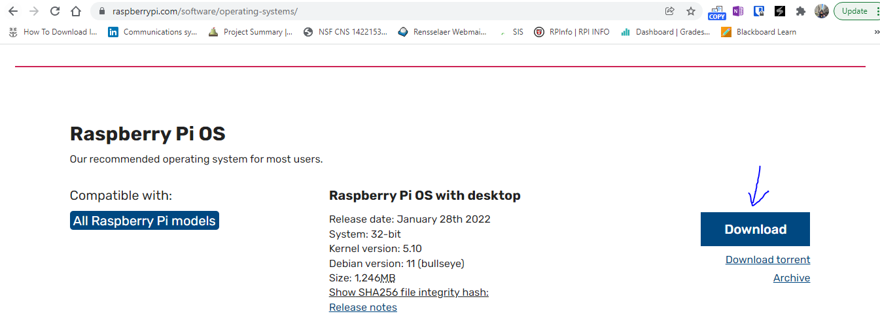

Step 3: Open Raspberry Pi Imager and click Choose OS:

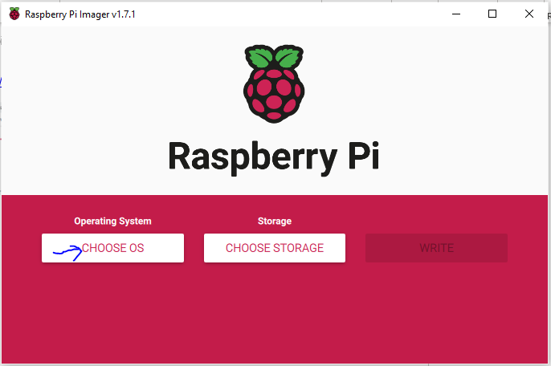

Step 4: Navigate to Use Custom and Choose your downloaded RaspiOS image file.
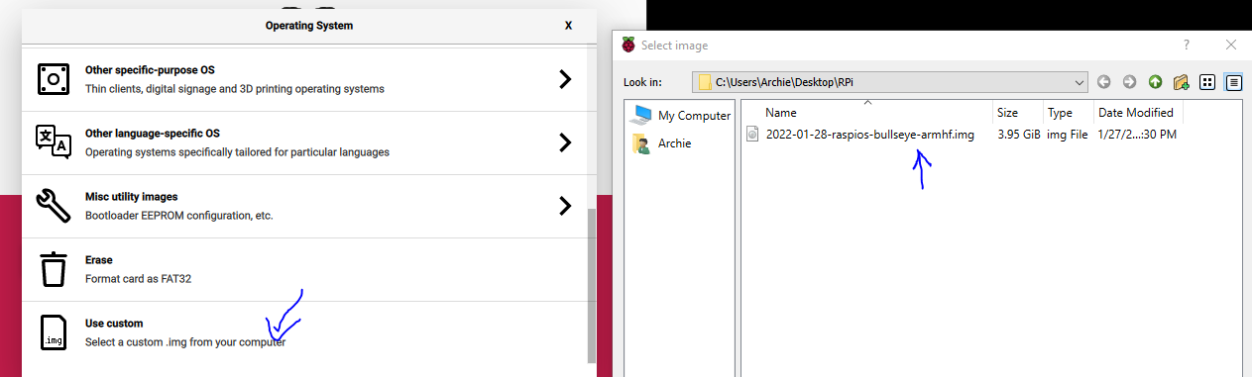

Step 5: Insert your SD card and click Choose Storage to select the SD Card and Write!

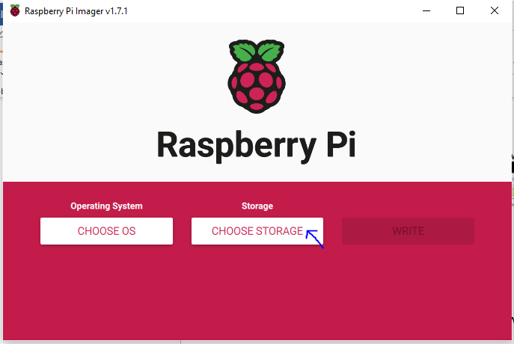
This should create a bootable SD card for your Raspberry Pi. Let us know if there are any issues with your Raspberry Pi and/or SD card and we’ll be happy to replace.

